20 March 2026

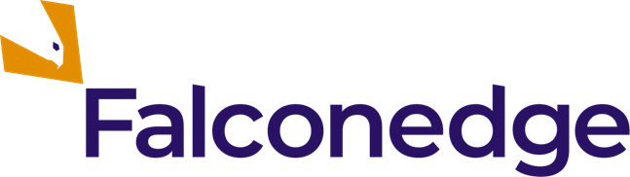

FALCONEDGE PLC
(the 'Company')

Result of AGM

Falconedge PLC (AQSE: EDGE | OTCQB: FEDGF), announces that at the Company's annual general meeting ("AGM"), held earlier today, all resolutions were duly passed.

Contacts

Falconedge PLC | Harbor Access Investor Relations (US)
Roy Kashi, CEO  +44 (020) 382-70278  Roy@falconedge.co.uk | Jonathan Paterson, Investor Relations  +1 475 477 9401  Jonathan.Paterson@Harbor-access.com
Aquis Corporate Adviser and Joint Broker

AlbR Capital Limited
+44 207 469 0930

Corporate Brokers | Investor Relations (UK)
Fortified Securities  Guy Wheatley  guy.wheatley@fortifiedsecurities.com  +44 7493 989014 | Tel +44 (0) 203 827 0278  IR@falconedge.co.uk
SI Capital

Sam Lomanto
sam.lomanto@sicapital.co.uk
+44 (0) 1483 413 500

The Directors of the Company accept responsibility for the contents of this announcement.

About Falconedge

Falconedge (AQSE: EDGE) provides turnkey hedge fund advisory services for asset and fund managers delivering expertise across fundraising, investor relations, DeFi and treasury strategy, and operational growth. Founded in 2025, Falconedge is positioned at the intersection of traditional finance and digital innovation. By integrating Bitcoin-native solutions with institutional advisory experience, the Company helps asset managers scale efficiently, attract capital, and deliver sustainable performance while creating asymmetric exposure opportunities for shareholders. By blending consulting expertise with Bitcoin as a strategic reserve asset, Falconedge seeks to scale client operations while creating asymmetric exposure opportunities for its shareholders. Please visit www.falconedge.co.uk, and follow the Company on LinkedIn and X.

